Project Design Phase-II
Technology Stack (Architecture & Stack)

Date | 31-01-2026
Team ID | LTVIP2026TMIDS73327
Project Name | AutoSage App using Gemini Flash
Maximum Marks | 4 Marks

Technical Architecture:
AutoSage follows a three-tier architecture consisting of a user interface layer, application logic layer, and data/model layer. The application allows users to upload vehicle images, which are processed using Gemini Flash AI to identify vehicles and generate structured insights such as brand, model, mileage, price range, resale value, and eco-efficiency. The system is deployed on cloud infrastructure to ensure scalability, performance, and availability.
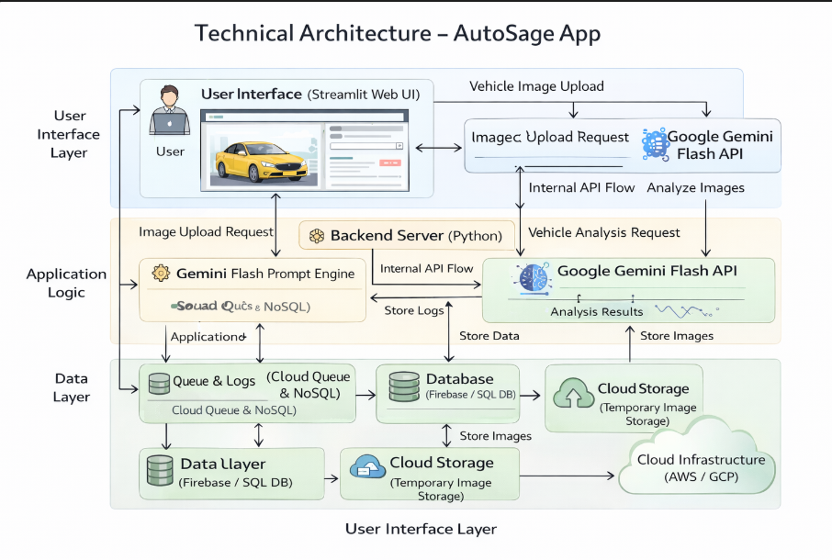
Table-1: Components & Technologies:
S.No | Component | Description | Technology
1 | User Interface | Allows users to upload vehicle images and view results | Streamlit Web UI, HTML, CSS
2 | Application Logic – 1 | Handles request processing and application flow | Python
3 | Application Logic – 2 | Processes vehicle image and extracts features | Google Gemini Flash API
4 | Application Logic – 3 | Generates summarized vehicle insights | Gemini Flash Prompt Engine
5 | Database | Stores user queries and vehicle metadata | SQLite / NoSQL
6 | Cloud Database | Cloud-based data storage for scalability | Firebase / Cloud Firestore
7 | File Storage | Temporary storage for uploaded images | Local File System / Cloud Storage
8 | External API – 1 | AI-based image understanding | Google Gemini Flash API
9 | External API – 2 | Vehicle reference and pricing data | Open Vehicle Data APIs
10 | Machine Learning Model | Identifies vehicle and extracts details | Multimodal Vision–Language Model
11 | Infrastructure (Server / Cloud) | Deployment and hosting environment | Local System / AWS / GCP

Table-2: Application Characteristics:
S.No | Characteristic | Description | Technology
1 | Open-Source Frameworks | Frameworks used to build the application | Python, Streamlit
2 | Security Implementations | Secure access and data protection | HTTPS, API Keys, Environment Variables
3 | Scalable Architecture | Supports increased users and data load | Three-Tier Architecture, Cloud Deployment
4 | Availability | Ensures continuous access to application | Cloud Hosting, Distributed Services
5 | Performance | Optimized for fast image analysis and response | Gemini Flash, Lightweight UI, Caching

References:
- NPL
- Generative AI
- About Gemini
- Gemini API
- Gemini Demo

